Sri.D.N.R.GOVT.DEGREE COLLEGE FOR WOMEN, PALAKOL.
DEPARTMENT OF POLITICAL SCIENCE

Best practice

Subject :-
As part of the best practice, pens were given to the students who completed their degree and prepared for the exams.
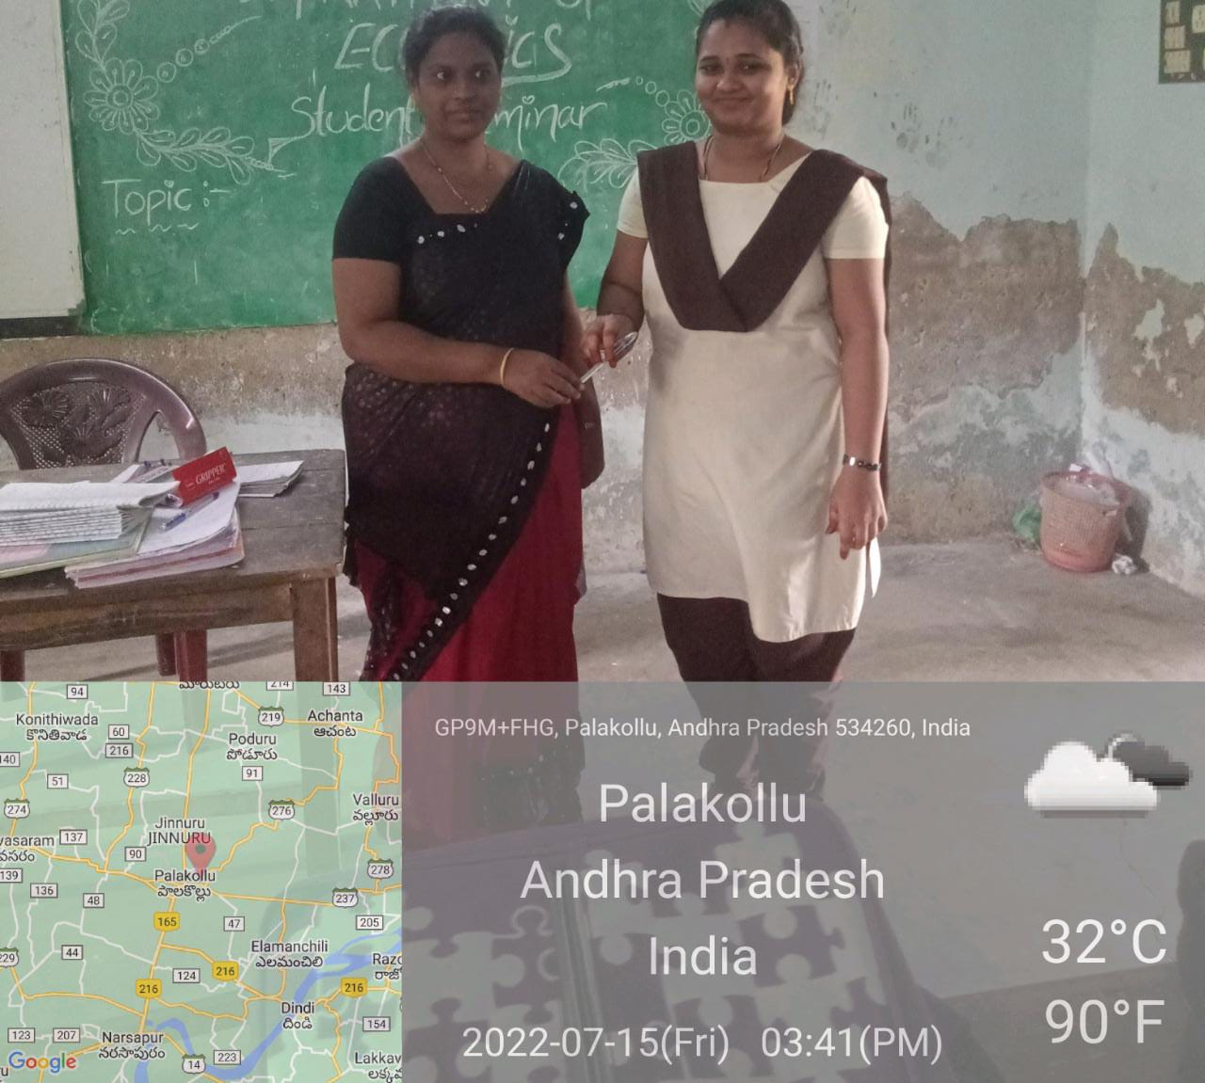

Objective:-
Students are enthusiastically preparing to write the exams.

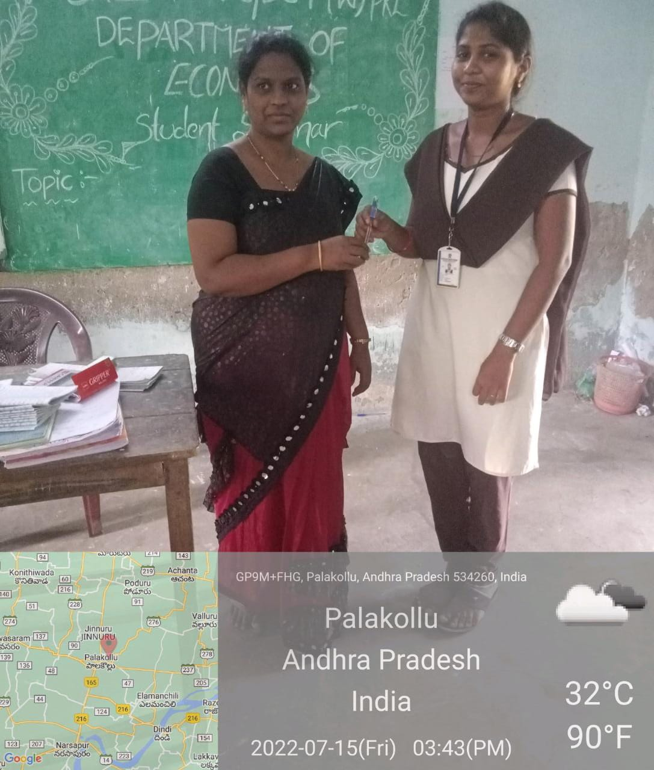

Outcome:-
Students learned how to encourage others.
Students learn to help others.
